Software Verification and Validation Project

Health Management System

California State University Fullerton

Contributors:

Samit Harish Sharma (CWID:888261328)

Ratik Shetty (CWID:888260478)

Guided by:

Prof. D Heckathorn

Cal State Fullerton Health Management System

**Business Process**

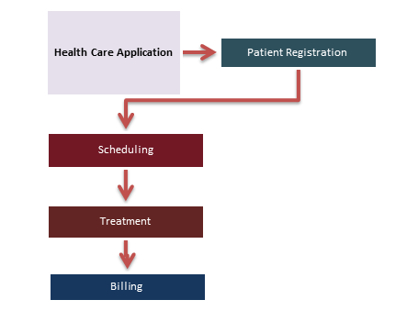

**Unit Testing:**

**Module Create Account:**

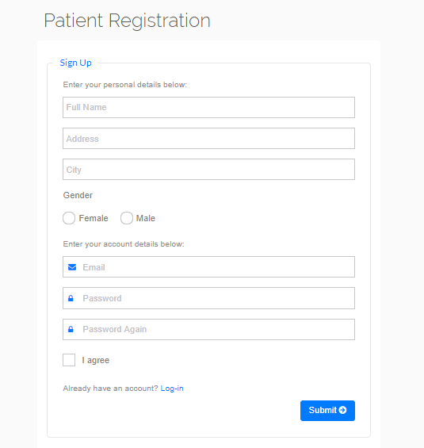

|  |  |  |  |  |  |
| --- | --- | --- | --- | --- | --- |
| Test No | Input | Expected | Actual | Result | Criticality |
| 1 | Full Name = qwerty123 | Shouldn’t accept numbers | Account created | FAIL | Medium |
| 2 | Gender Not Selected | Ask user to select gender | Account Created | FAIL | High |
| 3 | Email= qwertycom.in | Invalid Email | Account Created | FAIL | High |
| 4 | Password= ‘ ‘ | Enter Password | Account Created | FAIL | High |
| 5 | Password = qwerty  Password Again= qw | Password Doesn’t match | Account Created | FAIL | Medium |
| 6 | Password = A | Password must be more than 5 characters | Account Created | FAIL | Medium |
| 7 | Terms not agreed | Ask user to Agree Terms before creating account | Account Created | FAIL | Medium |
| 8 | Full Name = qwerty123 | Shouldn’t accept numbers | Numeric value not allowed in Full Name | Pass | N/A |
| 9 | Gender Not Selected | Ask user to select gender | Account Created | Pass | N/A |
| 10 | Email= qwertycom.in | Invalid Email | Please enter a correct email id | Pass | N/A |
| 11 | Password= ‘ ‘ | Enter Password | Please | Pass | N/A |
| 12 | Password = qwerty  Password Again= qw | Password Doesn’t match | Password Doesn’t Match | Pass | N/A |
|  | Password = A | Password must be more than 5 characters | Password not in correct format | Pass | N/A |
|  |  |  |  |  |  |

**Edit Profile Module:**

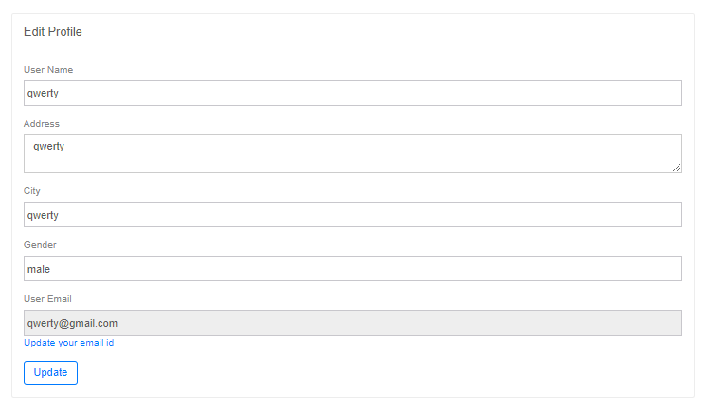

|  |  |  |  |  |  |
| --- | --- | --- | --- | --- | --- |
| Test No | Input | Expected | Actual | Result | Criticality |
| 1 | Gender = male123 | Shouldn’t accept number | Profile Updated | FAIL | High |
| 2 | User Name= qwerty123 | Shouldn’t accept Number | Profile Updated | FAIL | High |
| 3 | Gender = male123 | Shouldn’t accept number | Enter valid Gender | PASS | N/A |
| 4 | User Name= qwerty123 | Shouldn’t accept Number | Numbers not allowed | PASS | N/A |
| 5 | Update your email ID 🡪 email ID = qwerty.com | Invalid Email ID | Email updated | FAIL | High |
| 6 | Update your email ID 🡪 email ID = qwerty.com | Invalid Email ID | Enter Valid Email ID | PASS | N/A |
| 7 | Update User Name = ‘ ‘ | Please Enter User Name | Profile updated | FAIL | Critical |
| 8 | Update User Name = ‘ ‘ | Please Enter User Name | Please Enter a valid User Name | PASS | N/A |

**Appointment History**:

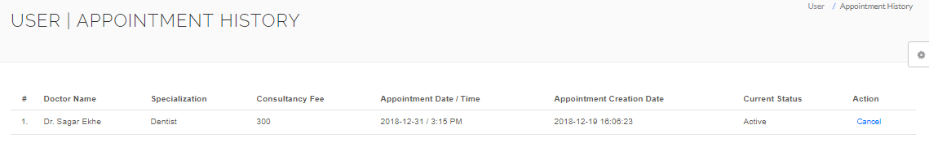

|  |  |  |  |  |  |
| --- | --- | --- | --- | --- | --- |
| Test No | Input | Expected | Actual | Result | Criticality |
| 1 | Booked Appointment | Current Status = Active | Current Status = Inactive | FAIL | Critical |
| 2 | Booked Appointment | Current Status = Active | Current Status = Active | PASS | N/A |
| 3 | Booked Appointment | Doctor Name =  Ex: “Sarita Pandey” | Doctor Name = “ ” | FAIL | Critical |
| 4 | Booked Appointment | Doctor Name =  Ex: “Sarita Pandey” | Doctor Name = Ex: “Sarita Pandey” | PASS | N/A |
| 5 | Booked Appointment | Under Action 🡪 Cancel Option | Under Action 🡪 Cancel option Disabled | FAIL | High |
| 6 | Booked Appointment | Under Action 🡪 Cancel Option | Under Action 🡪 Cancel option Enabled | PASS | N/A |

**Book Appointment:**

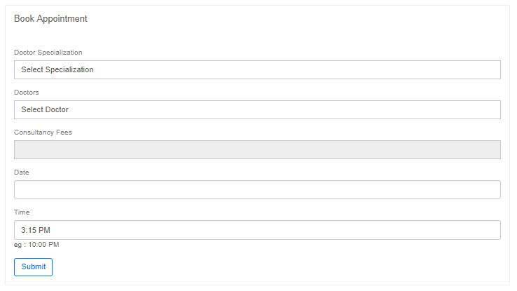

|  |  |  |  |  |  |
| --- | --- | --- | --- | --- | --- |
| Test No | Input | Expected | Actual | Result | Criticality |
| 1 | Click on Doctor Specialization field | Load drop Down list | No values to select | FAIL | Critical |
| 2 | Click on Doctor Specialization field | Load drop Down list | Doctor Specialization populated in Drop down list | PASS | N/A |
| 3 | Click on Doctors field | Load Doctors name in a Drop-down list | No values populated in drop down list | FAIL | Critical |
| 4 | Click on Doctors field | Load Doctors name in a Drop-down list | Doctors name populated in drop down list | PASS | N/A |
| 5 | Selected Doctors Specialization and Name | Populate Consultancy Fees | Consultancy field remain blank | FAIL | High |
| 6 | Selected Doctors Specialization and Name | Populate Consultancy Fees | Calculates Consultancy Fees | PASS | N/A |
| 7 | Selected Doctors Specialization, Name and clicked Submit | Please select Date and Time to Book Appointment | Appointment booked | FAIL | Critical |
| 8 | Selected Doctors Specialization, Name and clicked Submit | Please select Date and Time to Book Appointment | Please Select Date and Time | PASS | N/A |

**Integration Testing:**

|  |  |  |  |  |  |
| --- | --- | --- | --- | --- | --- |
| Test No | Input | Expected | Actual | Result | Criticality |
| 1 | Create Account 🡪 Enter User Name Password and click Create | Create User Account and Allow user to Login | No record created in Database. User unable to login | FAIL | Critical |
| 2 | Create Account 🡪 Enter User Name Password and click Create | Create User Account and Allow user to Login | User Record Created in database and user ale to login | PASS | N/A |
| 3 | Book Appointment 🡪 Enter all fields and click on Book | Create Booking record and display it in Appointment History page | No bookings record created | FAIL | Critical |
| 4 | Create Account 🡪 Enter User Name Password and click Create | Create User Account and Allow user to Login | No record created in Database. User unable to login | PASS | N/A |
| 5 | Appointment History 🡪 Click on Select Appointment | Set canceled flag to 1 | Status of cancel flag not changed | FAIL | High |
| 6 | Appointment History 🡪 Click on Select Appointment | Set canceled flag to 1 | Canceled flag set to 0 | PASS | N/A |

**Other Types of Hospital Management Testing:**

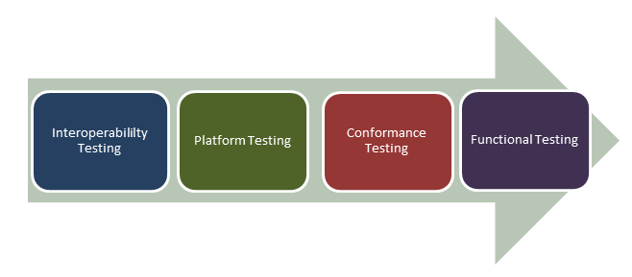

* **Functional Testing**: Testing management application against functional capabilities
* **Conformance Testing**: Conformance test hospital security requisites and industry frameworks
* **Platform Testing**: Testing of applications on Mobile platform and applications testing for cross-browser compatibility
* **Interoperability Testing**: Testing conformance to interoperability standards ( Eg; DICOM, HL7, CCD/CDA)

**Testing Challenges in Hospital Management System:**

Testing challenges in testing hospital management system application are no different than other web application testing.

* Requires expertise in testing, and usually it is high in cost
* Requires interoperability, compliance, regulatory, security, safety testing besides regular testing techniques (Non-Functional, Functional and Integration testing)
* Testing should be done keeping in mind the safety and regulatory standards- as any error can cause direct effect on patient's life
* Testing team needs to be well aware of the various functionalities, clinical usage, and the environment the software will be used for
* Health-care product should comply with various standards like FDA, ISO and CMMI before it can be used
* Cross dependency of software- testers need to ensure that any changes in one component or layer should not lead to side effect on the other.

**What we considered during testing:**

While testing software, we gave importance to below factors:

* Dates are important and needs to be accurate
* While designing test cases consider various parameters like different types of plan, members, criticality, patient’s health, life endangerment, etc.
* Complete knowledge of the domain is required.

**Testing tool used:**

**Codeception**URL - <https://codeception.com/>



Codeception supports all three testing types. Out of the box you have tools for writing unit, functional, and acceptance tests in a unified framework.

|  | **Codeception Unit Tests** | **Codeception Functional Tests** | **Codeception Acceptance Tests** |
| --- | --- | --- | --- |
| Scope of the test | Single PHP class | PHP Framework (Routing, Controllers, etc.) | Page in browser (Chrome, Firefox, or PhpBrowser) |
| Testing computer needs access to project’s PHP files | Yes | Yes | No |
| Webserver required | No | No | Yes |
| JavaScript | No | No | Yes |
| Additional software required | None | None | <ul><li>For WebDriver: Selenium Server or PhantomJS (deprecated)</li><li>For PhpBrowser: None</li></ul> |
| Test execution speed | High | High | Low |
| Configuration file | unit.suite.yml | functional.suite.yml | acceptance.suite.yml |

**Testing tool used:**

**Redmine**URL - <https://codeception.com/>



**Test Report:**

* The application worked and functioning was as per the requirement
* It has module integration issues and unit test cases failed for a few of the modules
* A huge number of bugs were either Critical or Major
* The application passed testing as per its defined specifications in the following tests:

Stress Testing

Load Testing (10000 users)

Endurance Testing

Spike Testing

Volume Testing

**Our Contribution:**

We have tested the project and fixed the defects in the application along with the development of additional modules.

We wrote manual and automation test cases and used redmine for defect tracking and to take an estimate of time taken to fix the defect.

**Project GitHub link:**

[**https://github.com/samit100/HMS.git**](https://github.com/samit100/HMS.git)

**Hospital/Health Management System**

URL - <https://codeception.com/>

About the project :

Here, User has to Login as Patient, Doctor OR Admin to use the system. From Patient’s login, a user can Book an appointment with any doctor and check appointment history. From Doctor’s login, a user can view Appointments. From Admin’s login, a user has access to each and everything. Admin can manage doctors, patients, Add Doctor specialization, and check Doctor’s and Patient’s session logs. This system makes easy management of hospital for the patients as well as doctors.The design of this project is pretty simple and the user won’t find it difficult to understand, use and navigate.

**How to run the project?**

You’ll need XAMP Server or WAMP Server. Put the file inside “c:/wamp/www/” or “c:/xampp/htdocs/”. Go To “localhost/phpmyadmin” in any browser and create Database (name according to SQL file).In that Database, Import the SQL file and finally go to URL: “[http://localhost/file_name/phpfilename](http://localhost/file_name/)”  
*Don’t Forget To create a database and import SQL file to run.*

**Features:**

Login Systems (Patients/Admin/Doctor)

Book Appointment

Manage Patients, Doctors

Add Doctor Specialization

**Login Details:**

Login Details for admin : admin

Password :Test@12345

Login Details for Patient: test@gmail.com

Password :Test@123

Login Details for Doctor: test@demo.com

Password : Test@123